ELECTRIC POWER DISTRIBUTION SYSTEMS
František Křižík, Thomas Alva Edison, Jára Cimrman
Abstract: The abstract of paper uses style Times New Roman 10 pt and should not be longer than 100 words. The formal aspects of the papers will be reviewed by publishers and, when appropriate, returned to authors for corrections or additions. Papers in PDF should be sent to e-mail address am2026@kme.zcu.cz till March 14, 2026. The registration ID and the name of the first author will identify the file, i.e. "001_Krizik.pdf".
Keywords: light bulb; battery; Dissolved and Drained; The Greatest Czech
- Introduction
The paper must be written in English. It should contain and be structured in the following way: introduction (problem statements, application area, research course), problem description, results, conclusion and references.
- Information
Use A4 format. A single column layout is used. The paper is restricted to 2 – 6 pages. The margin settings are on the first page is equal to 2.5 cm on the left, right and bottom of the page and 5 cm on the top of the page. The margin settings on the other pages are equal to 2.5 cm on the all sides of the page. The main body of the text is in Times New Roman 12 pt, justified. The first line of paragraph must be indented by 1.25 cm. Please, do not number pages of document. Each paragraph should have a top margin of 6 pt.
  - Titles And Subtitles
For titles of chapters use style Times New Roman Bold 14 pt (style = Title 1). Subtitles of chapters must be in style Times New Roman Bold 12 pt (style = Title 2). Before respectively after each title or subtitle should be margin of 18 pt respectively 12 pt.
- Graphic Material
Figures, i.e. illustrations and pictures should be close to place where they are referenced in the text. You should put a picture to the table with two lines, the first line should be used for a picture and the second line should be used for caption of the picture (Figure 1.). The table should be without border.

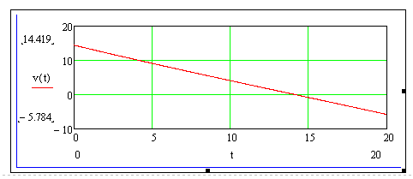
Figure 1: Title of figure uses style Times New Roman 10 pt, put the “Figure x:” part of the caption in bold type.
If you want to place two or more pictures side-by-side across the width of the page, putting them into a table with the appropriate number of columns allows you to place their captions beneath them correctly (Figure 2 and 3.).
Pictures in the table should be centred horizontally and vertically. Figures have to be made in high quality (in order to achieve good quality, at least 300 dpi is recommended). Generally, please, make sure that all the objects are actually embedded in your file and not just linked to other files on your hard disk.

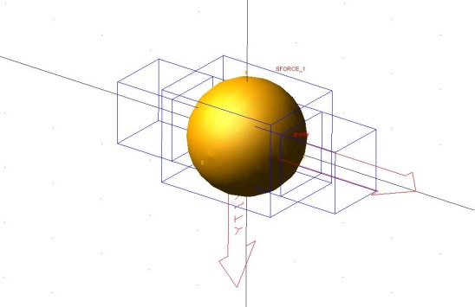 | 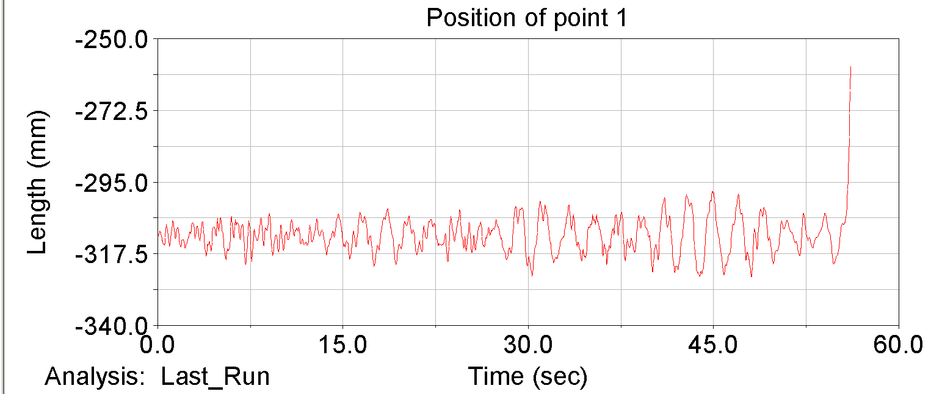
Figure 2: Times New Roman 10 pt, put the “Figure x:” part of the caption in bold type. | Figure 3: Times New Roman 10 pt, put the “Figure x:” part of the caption in bold type.

Equations should be centred and numbered consequently, starting from (1). For equations placing, please, use two tabulators. The first tabulator (for equation) is place in the centre of page with centre alignment. The second tabulator (for equations number) is placed on the right side of the page with right alignment.
(1)
Tables (like figures) should be placed in the text close to place where they are the first referred to. Treat them like figures but as is shown for Table 1. Use the last no bordered row for table caption.

Style name | Typeface | Size | Alignment | Line spacing
Paper title | Times New Roman Bold | 16 pt | Centred | Single
Chapter title | Times New Roman Bold | 14 pt | Justified | Single
Author | Times New Roman | 12 pt | Centred | Single
Abstract text | Times New Roman | 10 pt | Justified | Single
Figure caption | Times New Roman | 11 pt | Centred | Single
Normal text | Times New Roman | 12 pt | Justified | Single
References | Times New Roman | 11 pt | Justified | Single
Table caption | Times New Roman | 11 pt | Justified | Single
Table text | Times New Roman | 11 pt | Justified | Single
Table 1. Styles in use in the preparation of this document.
- Referencing Convention
References should be indicated on the text by a sequence number in square brackets [1]. They should be numbered in the order in which they appear in the text. The reference list at the end of this sample paper contains examples of the referencing of a journal paper, a conference paper, a book and other references, the style of which should be followed in preparing your paper. Note that the references are generated in accordance with ISO 690; therefore, authors can use the online generator at https://www.citace.com/.
Acknowledgement
This work was supported by grant …
References
- FIRST, Name; SECOND, Name and THIRD, Name. Title of journal paper. Journal title in italics. 2017, vol. 20, no. 2, pp. 100-110. Available from: https://doi.org/10.1000/182.
- FIRST, Name and SECOND, Name. Paper in proceedings. In: THIRD, Name (ed.). Title of proceedings in italics. City: Publisher, 2000, pp. 190-193. ISBN X-XXXXX-XXXX. (Alternatively, the DOI identifier may be used.)
- FIRST, Name and SECOND, Name. Paper in proceedings. In: Title of unprinted proceedings in italics. CD-ROM. City: Publisher, 2000, p. 57-60. ISSN XXXX-XXXX. (Alternatively, the DOI identifier may be used.)
- FIRST, Name. Title of book in italics. 2nd Ed. City: Publisher, 2005. ISBN XX-XXXX-XXXX.
- FIRST, Name. Title of book chapter in italics. City: Publisher, 2010, pp. 213-252. ISBN XX-XXXX-XXXX.
- FIRST, Name and SECOND, Name. Title of eBook. Online. 7th Ed. City: Publisher, 2024 [Accessed 2025-12-01]. ISBN X-XXXXX-XXXX. Available from: http://www.url-to-book.com

Title(s), Name, Surname; Full title of the Institution; Street, ZIP-code City, Country, E-mail
For example: doc. Ing. František Křižík, Ph.D.; Technical University of Stádlec, Department of Electrical Engineering; Táborská 2, 46117 Stádlec, Czech Republic, f.krizik@ipm.cz
all is written in Times New Roman 10 pt.

